Maulana Abul Kalam Azad University of Technology

BF Block, Sector 1, Vidyanagar, Kolkata,

West Bengal 700064



**Project Report on**

Predicting The Energy Output of Wind Turbine Based By Using

Machine Learning

**Department of Mechanical Engineering**

**Submitted by**

**SHOUVIK KHAN 14200719057**

**SAYANTAN DAS 14200719058**

**MIRAJUL HOQUE 14200719059**

**PARTHAJIT RANA 14200719060**

**SATTRAJIT SAHA 14200719061**

**PANKAJ KUMAR 14200719062**

**SOMNATH DAS 14200719063**

**Under the guidance of**

**PROFESSOR ANIRBAN BOSE**

**Department of Mechanical Engineering**

**Submission Date:** **23.07.21**

**Table of Contents**

**Page no**

**CHAPTER- 1 INTRODUCTION 3**

* 1. Overview 3
  2. Purpose 4
  3. Motivation 4

**CHAPTER- 2 ABSTRACT 5**

* 1. Existing Problem **5**
  2. Proposed solution **5**

**CHAPTER-3 THEORETICAL ANALYSIS 6**

* 1. Block Diagram **6**
  2. Hardware / Software Designing **7**

**CHAPTER-4. DATASETS 7**

**CHAPTER-5. DATA VISUALIZATION 8**

**CHAPTER-6. FLOWCHART 9**

**CHAPTER-7. RESULT  10**

**CHAPTER-8. ADVANTAGES AND DISADVANTAGES 10**

**CHAPTER-9. APPLICATIONS 11**

**CHAPTER-10. CODE 11**

10.1. Libraries used **11**

**CHAPTER-11. CONCLUSION 12**

**CHAPTER-12. FUTURE SCOPE 12**

**CHAPTER-13. Result and Demo 13**

**14. REFERENCES 14**

**CHAPTER: 1 INTRODUCTION**

Wind energy plays a major role in providing energy worldwide. Renewable energies are set to conquer the global energy system faster than any other fuel in history. A wind farm's energy output depends heavily on the weather conditions present at its site. A wind performance forecast is an estimation of the production expected of one or more wind turbines. If the output can indeed be predicted more effectively, the energy providers can more effectively organize the joint development of various energy sources to avoid expensive overproduction.

They have always been the main energy source of human; industrialization cannot be realized without the consumption of fossil fuels; they are the foundation of modern transportation. On the other hand, the combustion of fossil fuels globally results in excessive amount of greenhouse gas that endangers the health of our environment. The abnormal raise of carbon dioxide level, global warming and acid rain can be all attributed to burning fossil fuels.

**1.1** **Overview**

Wind power generation differs from conventional thermal generation due to the stochastic nature of wind. Thus, wind power forecasting plays a key role in dealing with the challenges of balancing supply and demand in any electricity system, given the uncertainty associated with the wind turbine power output. Accurate wind power forecasting reduces the need for additional balancing energy and reserve power to integrate wind power.

For a wind turbine that converts wind energy into electricity power, a real-time prediction system of the output power is significant. a prediction system is developed with a method of combining statistical models and physical models. In this system, the inlet condition of the wind turbine is forecasted by the auto regressive model.

**1.2** **Purpose**

Wind energy plays an increasing role in the supply of energy world-wide. The energy output of a wind turbine is highly dependent on the weather present condition.

If the output can be predicted more accurately, energy suppliers can coordinate the collaborative production of different energy sources more efficiently to avoid costly over productions. Predicting full load electrical power output of a base load power is important in order to maximize the profit from the available megawatt hour.

* 1. **Motivation**

Machine learning is a field of computer science that focuses on improving the performance of the program by itself with experience. In this technique, the machine is not told how to solve the problem explicitly; instead, the experience is given to the device as different inputs, and the outputs are typically a model that can address future issues of the same kind. The complete procedure of machine learning includes several steps. First, past experience is usually gathered for the training in the later stage. At that point, the type of a unique target function is resolved, which portrays the relationship between inputs and outputs. From that point onward and machine learning model is chosen to estimate the target function. At last, a fitting calculation is utilized to assemble the model from the training models. The process of machine learning is summarized in.

The elimination of variability of the wind is not possible, but by using machine learning, we can make wind power sufficiently more predictable and valuable. This will also help bring greater data rigor to wind farm operations, as these techniques can help wind farm operators make faster, more data-driven, and smarter assessments of how their power output can meet electricity demand. The primary aim of this research work is to predict wind turbine output power using machine learning techniques. Since a very limited study has been done on wind turbine power prediction using machine learning it is of greater interest to us how well it performs in this field.

**CHAPTER:2 ABSTRACT**

Renewable energy is the most important topic in the world at present. It was identified that the fossil fuel reserves in the world are diminishing rapidly and no reserves were identified. In addition to that, energy generation from fossil fuels may cause many environmental problems like emission of greenhouse gasses, global warming and acid rains. Renewable energy sources play a major role in this type of situation Renewable energy is the energy that is extracted from renewable sources such as Winds, Sunlight, Rain, Tides, Waves, Geothermal heat etc. Wind power is the fastest-growing form of renewable energy at the present time in terms of reduced mechanical stress, improved power electricity. Wind turns the propeller-like blades of a turbine around a rotor, which spins a generator, which creates electricity.

**2.1**  **Existing Problem**

Accurate wind power forecasting reduces the need for additional balancing energy and reserve power to integrate wind power.

For a wind farm that converts wind energy into electricity power, a real-time prediction system of the output power is significant.

Wind power generation differs from conventional thermal generation due to the stochastic nature of wind.

Thus, wind power forecasting plays a key role in dealing with the challenges of balancing supply and demand in any electricity system, given the uncertainty associated with the wind farm power output.

**2.2 Proposed solution**

This Project examines and compares machine learning regression methods to develop a predictive model, which can predict hourly full load electrical power output of a combined cycle power plant. The base load operation of a power plant is influenced by 3 main parameters, which are used as input variables in the dataset. Such as

|  |  |  |  |  |
| --- | --- | --- | --- | --- |
| **LV Active Power (kW)** |  |  |  |  |
| **Wind Speed (m/s)** |  |  |  |  |
| **Theoretical Power Curve (KWh)** |  |  |  |  |
| **Wind Direction (°)** |  |  |  |  |

These parameters affect electrical power output, which is considered as the target variable. For this we are building web application to enter the inputs and view the result.

**CHAPTER: 3 THEORITICAL ANALYSIS**

Wind Power Forecasting (WPF) has applications in generation and transmissionmaintenance planning, energy optimization as well as in energy trading. WP models exists at different scales and they can be useto predict the production for a single WT to a whole Wind Farm.

**3.1 Block Diagram**

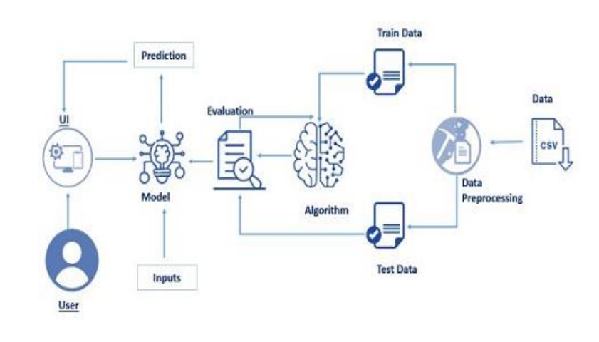

**3.2 Hardware / Software Designing**

* Importing Data Set
* Evaluating Any Null Values
* Training and Testing Dataset by applying Multi linear regression method.
* Model Building.
* Import Model Building Libraries
* Initializing the model
* Configure Learning Process
* Train and Test Model
* Optimize and save the Model
* Application Building
* Create HTML file
* Build Python Code

**CHAPTER: 4** **DATASETS**

 The dataset has been collected from Kaggle.

 The data in the file are:

● **Date/Time** (for 10 minutes’ intervals).

●**LV ActivePower (kW):** The power generated by the turbine for that

Moment.

●**Wind Speed (m/s):** The wind speed at the hub height of the turbine (the wind speed that turbine use for electricity generation)

●**TheoreticalPowerCurve (KWh):** The theoretical power values that the

Turbinegenerates with that wind speed which is given by the turbine manufacturer.

●**Wind Direction (°):** The wind direction at the hub height of the turbine (wind turbines turn to this direction automatically).

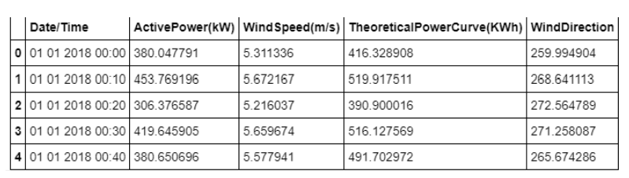

**CHAPTER: 5 DATA VISUALIZATION**

The label for the data set is PE which is a continuous variable. Data Visualization is one of the powerful parts of Data Science to infer logic form data and find some patterns.

The factors affecting PE are also continuous. So, in order to analysis the dataset using graphs we use the plots like heat map.

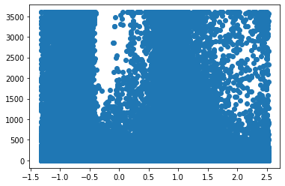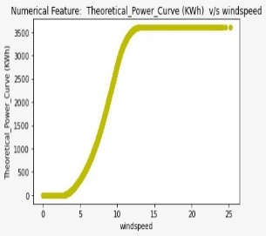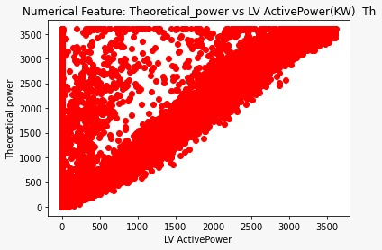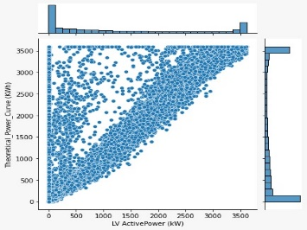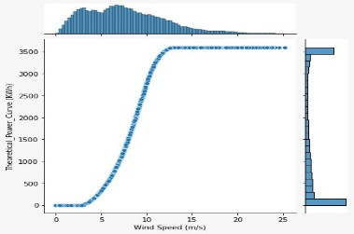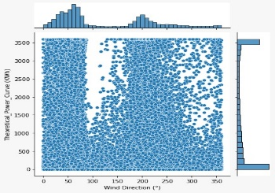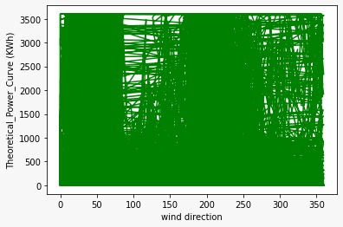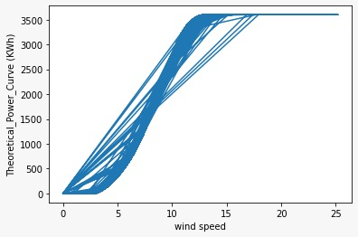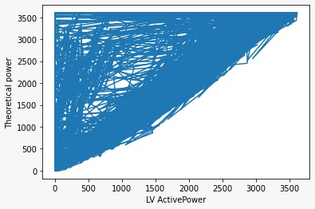

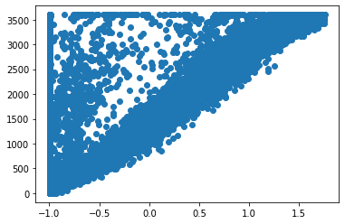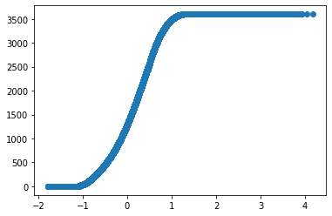

Heat map is the plot of values of correlation between the variables in data set. The correlation values are plotted using heat map

.

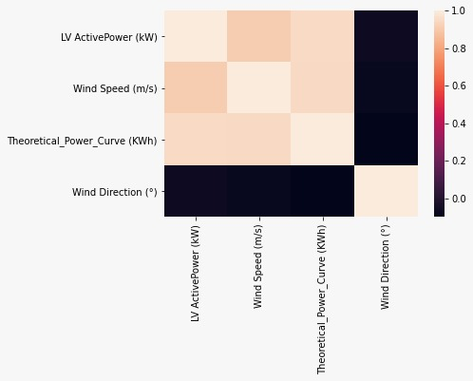

**CHAPTER: 6 FLOWCHARTS**

* Data Collection.
* Collect the dataset or Create the dataset
* Data Pre-processing.
* Import the Libraries.
* Importing the dataset.
* Checking for Null Values.
* Data Visualization.
* Taking care of Missing Data.
* Label encoding.
* Feature Scaling.
* Splitting Data into Train and Test.
* Model Building
* Training and testing the model
* Evaluation of Model
* Application Building
* Create an HTML file
* Build a Python Code

**CHAPTER:7 RESULT**

Therefore, by analyzing the given data, we can say that PE is increasing with AT and V. While PE is decreasing with the increment of AP.

So, in order to increase energy production of power plant (PE), we need to operate the combined cycle power plant at low AT, low V, high RH, and high AP. There can be some more Data Science Techniques which can be applied to find some more patterns form the given dataset.

**CHAPTER: 8 ADVANTAGES AND DISADVANTAGES**

* **ADVANTAGES: -**

1. There are two advantages to analysis data using multiple regression model has ability to determine the relative influence of one or more predictor variables to criterion the value.
2. It has the ability to identify the outliers or anomalies.
3. Each independent variable model has its own slope relative to independent variable for the given set of independent variables.

* **DISADVANTAGES: -**

1. The disadvantages of using multiple regression usually the outcomes are come downs to the dataset the data being used.

**CHAPTER-9 APPLICATIONS**

1. The model develops to predict the electrical power output in the easy way for the peoples.
2. The involvement of this peoples will clearly predict every month of the how much power can produce by the Predicting the Energy Output of Wind Turbine Based on Weather Condition can easily see in this electrical power output.

**CHAPTER-10 CODE**

The coding portion were carried out to prepare the data, visualize it, pre-process it, building the model and then evaluating it. The code has been written in Python programming language using Collab Notebook as IDE. The experiments and all the models building are done based on python libraries.

The code is available in the Git repository given in following link:

**10.1 Libraries used**

* **Numpy**
* **pandas**
* **matplotlib**
* **Sklearn**
* **scatter plot**
* **joint plot**
* **line plots**
* **Logistic Regression**

**CHAPTER-10** CONCLUSION

This project presents a technical application of the recent progress of We will be considering the Random Forest, Linear Regression model-based processing. It will be predicting full load electrical power output, in order to maximize the profit from the available megawatt hour. Furthermore, the finding from the model building to the pros and cons of the model are also specified. In addition, applications, future focus, and solutions are provided. At present, the design and use of this Random Forest, Regression model. our ultimate goal is to using Machine Learning through algorithm of Random Forest, Regression model tools to predicting the energy output.

**12. FUTURE SCOPE**

* The interpretation of the learned Random Forest, Regression model with mathematical formalization and clear explanation, is quite poor. One way to tackle this issue is from qualitative understanding based on visualization.
* The scope of Machine Learning is not limited to the investment sector. Rather, it is expanding across all fields such as banking and finance, information technology, media & entertainment, gaming, and the automotive industry.
* Machine learning is merely based on predictions made based on experience. It enables machines to make data-driven decisions, which is more efficient than explicitly programming to carry out certain tasks.

* Model Building
  + - Dataset
    - Collab Notebook
* Application Building
* HTML file
* Anaconda Navigator
* Visual Studio Code

**CHAPTER-13. Result and Demo**

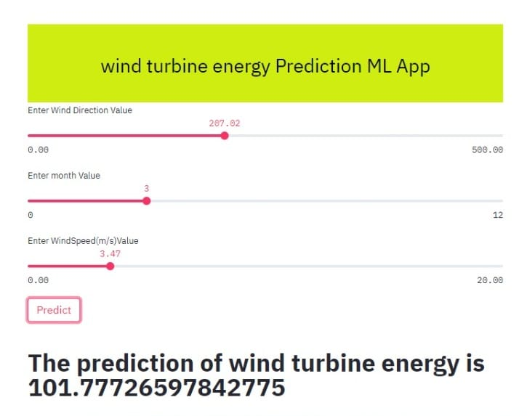 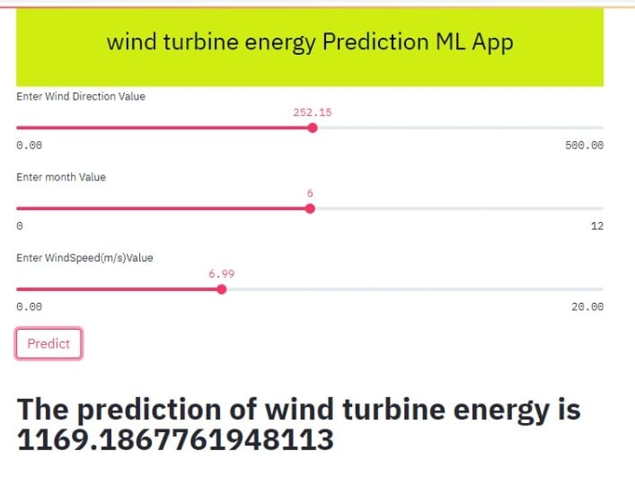

As u can see in the figure of the model. On giving the wind speed, wind direction and the month the model will predict the wind turbine power energy for different input the model will give the output.

**13. REFERENCES**

* Long-term wind speed and power forecasting using local recurrent neural network models IEEE Trans. Energy Convers.
* Brower M 2012 Wind Resource Assessment: A Practical Guide to Developing a Wind Project (New York: Wiley).